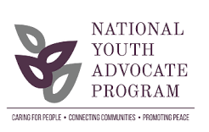 Webinar Guidelines
At NYAP, we strive to make trainings accessible for all and as such conduct many trainings for parents and employees virtually. We are also dedicated to maintaining high standards of quality and integrity in all trainings. Therefore, we respectfully ask that you abide by the following webinar training guidelines.
Virtual trainings are not for everyone. If you unable to uphold these requirements, please contact your licensing staff to learn about other training opportunities.
To receive training credit:
Please attend the entire Webinar Training. We cannot give partial credit for those who leave trainings early or come late.
After you log on, please sign your first and last names with your location (city/state) in the chat box.
You must have a working camera to participate. CAMERAS MUST BE TURNED ON & you must be visible in the frame. If your camera is not on & we cannot see YOU, you will be removed from the training.
Please be ACTIVELY ENGAGED & FOCUSED ON TRAINING (NOTE: If you are driving a vehicle, attending other events, or engaged in any other activities while attending training you will be removed from the training).
Trainings start on time & will be locked 15 minutes after the start time; please plan to arrive early.
Please be advised that virtual trainings are recorded and may be used for future training purposes

